**PROBLEMS**

* A user need to click ‘GO’ to get to the homepage.

They could have directed the user directly to the homepage rather than going through a page then click ‘GO’ button to land on the home page.

* Homepage takes time to load.
* Logo too big.
* Poor color contrast of elements across the site.
* Poor usability.
* Its hamburger menu**hides the primary and secondary navigation**.
* Browsing products is not a straightforward experience on the Zara website.
* Quirky aesthetic
* Keeping the aesthetic (also known as “delight” from the first paragraph) minimal. Try not to overload the page with too much.
* Accessibility issues.
* **Violation of Jakob’s law, texts in all caps**, **low contrast colors for small-sized fonts** .
* Font size of content too small.
* Navigation on the bottom of the page doesn’t work. Its just for the picture on the vertical slide. With slider user have to put more effort to get to the content which is Frustrating for users. When Sliding down on homepage it takes control of the scroll.
* Vertical slide doesn’t promote a good ux.
* Horizontal slide are not good.

Remove vertical and horizontal slide.

* UX- assistance, chat box
* UX- Navigation bar hidden behind the hamburger menu, user have to look around for that menu. No easy access.

The category could have listed at the top

* UI- Item list not categories;

could have being top/bottom/pants

* UI-Item list is too clumped together, spacing issue happening; require spacing
* Navigation is difficult to read when there an image behind it.
* Side button ’MEN’ too small. They are actual item that they want users to go through don’t know why its so small.
* UI- No product category linked in the footer.

Link the product in the footer, a lot of free space available.

* UI- On the product page, it shows only one product as default and white space beside. It’s a waste of space as a user they want to see more than one item at once and do not have to waste time scrolling.
* Its like a fashion catalog rather than an ecommerce website.
* After at least 5 scroll the user get to see 10 items. Takes time to scroll longer to see product and to see multiple product at once.

Show more than one product as default. YOU CAN CHANGE THE VIEWPOINT USING THE SLIDER. Many user prefer to view item in a more traditional grid layout to.

* No define layout, its is just a mix of grid patterns, widths and column size. The image is so big but the details of this items are so small.

Make a uniform layout, use a heavier font weight so it stands out more.

* Large image small text.
* Same product shown multiple time.
* UI- Search bar is randomly place on the right side, floating kind of in mid-air. It looks very lo-fi as well and it’s not really that prominent on the page. not noticeable/ too small for an e-commerce website.

Make it bigger since that something users are going to be using.

* While scrolling down the ‘ZARA’ logo overlap the picture
* When viewing an item, Too much of white space
* Details written too small. Difficulty reading text and information

Increase font size

* Font color too pale; Light grey.

Use darker font color

* UX- Its slow, Need a lot of scrolling to see angle picture.

Combining all the images into one little container to see it at once.

* UX- scroll down get items that you can pair it with which is nice, they make you want to buy more and spend time more on their website. Good UX.
* Half description of product is shown on the right and other half on the left. ONLY ON LAPTOP.

All could have being on the same side or below the picture to get to see it at once. The description could have being centered with the image it would have being better.

* Material description consists of button view more then clicking to it scrolling on view more ….
* While scrolling down the ‘ZARA’ logo overlap the description
* No channel for customer feedback.
* No dollar or Euro sign
* No custom order available regarding sizing.
* No variety of color available
* Join our newsletter
* Too much of white space.

They could have centered the information

* BASIC INFORMATION ON DATA PROTECTION, every more info has the same information PDF of privacy policy, useless checking the same things every time.
* Help????
* Login
* Register, font weight too small and color too light, problem in reading information. Wrong details might be enter by user.
* When add item to cart, we get a pop up but doesn’t show the current item we added rather show the first item we added. The user have to scroll down to see the current item.
* If the user go to cart only the first 3 items is display. No indication where the rest of the items are, it just say 5 in cart. A User may play around scroll horizontally to find the other ones, which is not how human prefer. They are usually presented all items on the page vertically.
* Total not visible at all. Someone might not notice it.
* Payment: continue shipping cost, continue choose card, visa info, all… while scrolling on items its slow. Price/total barely noticeable
* Join Life- Information capitalized, takes space. Logo and navigation bar overlap the content on the page.
* Contact customer service, they could have listed the things that a user might need help with directly on the page rather than to click on ‘access’ button to get help about specific things.
* Difficulty navigating through the site.
* Confusing product images.
* Difficulty reading texts/information.
* The issue with the men’s section is that there is a section called SeerSeeker. Based on its photos, it seems like a fabric, but there’s no description saying what it actually is. This is an issue because it can steer customers away since they do not know what it is.
* The issue with its UI is that in order to switch sections (like women to men or kids to beauty), the user has to click on the large Zara icon to refresh the filters. Why not just have the sections be available to have in the menu?
* This is the biggest issue with Zara’s website. Many of the pictures are too big, and words are too small to a point that you have to squint. Zara gives its users too much customization. Users can change the background, give voice commands, change the contrast, etc. This is an overload for new users, and can confuse them to a point to leave the site.
* Another huge issue is its large Zara icon that will bring the user to its homepage. The icon will always stay on the left side of the page and can even overlay in front of pictures. While it is nice to have, its visually annoying if you scroll through a clothing section
* difficulty of navigating around Zara’s website or the website was too busy leading them to shop at one of Zara’s competitors.

***Cohesive minimalist design***

* **Over half** of the participants said they wanted a more simplified interface for navigation, including more pictures of the product without the need of having to scroll up and down.
* Too much clicking is a turnoff for most users

## Not Easily Found

1. A navigation header should be easily found and not cause any effort or thinking
2. The coloring blends in with the dark background making it harder to find
3. [**37% of users claim they get annoyed by poor design and navigation on the website and that’s the main reason they leave.**](https://komarketing.com/files/b2b-web-usability-report-2015.pdf)
4. Aesthetic Usability Effect states, **“Users often perceive aesthetically pleasing design as design that’s more usable”**
5. The search bar should not be in the middle. The human eye naturally looks in the middle which is where their logo should be

## Problems

1. Menu in the middle blends in with pictures of the models
2. If a product is “New” or a “Best Seller”, the coloring should be bright rather than black
3. The user cannot click through different photos of a product but instead has to click directly on the product to be taken to a separate page and from there view multiple pictures by scrolling up and down
4. Filters menu is not as easy to identify which can be annoying for the user
5. Unnecessary to have the product’s size options to be vertical when there can be buttons in its row to conserve space
6. The user has to scroll up and down to see the product they selected rather than seeing multiple images at first glance
7. Selecting the color of the product should be ABOVE the button “Add to Cart” rather than its current position of being below the button

### **The Challenge**

While Zara claims to [put customers at the centre](https://www.forbes.com/sites/pamdanziger/2018/04/23/zaras-difference-pull-people-in-not-push-product-out/?sh=4816c9fb23cb) of their brand, users online have [**expressed difficulties and issues in the usability** of Zara’s site](https://www.dailymail.co.uk/femail/article-7801151/Zara-fans-claim-impossible-shop-stores-website-models-bizarre-poses.html), including many of my friends. This prompted me to evaluate Zara’s web presence and find a way to **improve their site** while **working within their established brand** and creative direction.

**Solution**

## Absolute Simplicity

1. Navigation bar is easily identifiable and not hidden thus preventing a user pain point
2. Four options per side help alleviate a user’s pain point. We want the user to not think but instead inherently know how to navigate this website by adding some familiarity from other sites
3. Sale will be in the color red to be more eye-catching
4. Zara has stores in over 96 different countries and having the ability to change the currency at the top should be a must
5. Zara’s logo should be in the middle. The human eye naturally looks towards the middle

## Bolder Design

1. Menu does not blend but is instead easily identifiable and stands out
2. The filters for a product are easy to identify compared to the current user interface layout
3. Products that are either “New” or a “Best Seller” are more eye-catching with labeled inside a red box
4. Instead of one large picture and having to scroll up and down to see the model’s outfit, the user is presented with 4–5 images that they can click to expand
5. Pagination at the top to show the user their path on how they got to where they are currently
6. Notes dropdown that describes the outfit and gives details about the model and what size they are wearing. E.g. I am 6'1" and I find myself too often buying shirts that are either way too small or too large. Having a reference point of how tall and big a model is can help alleviate a consumer’s pain point.
7. Social media campaign to get consumers to share their outfits and spread Zara’s name on social media
8. User is presented with an easy sequential process of having to select a size and then color before they can click the button “Add to Cart” compared to the current user interface layout

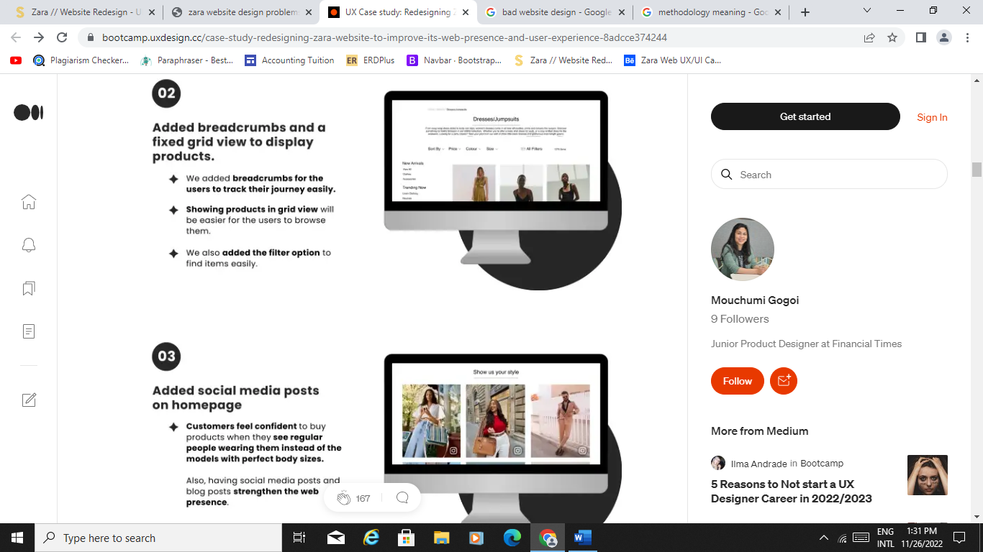

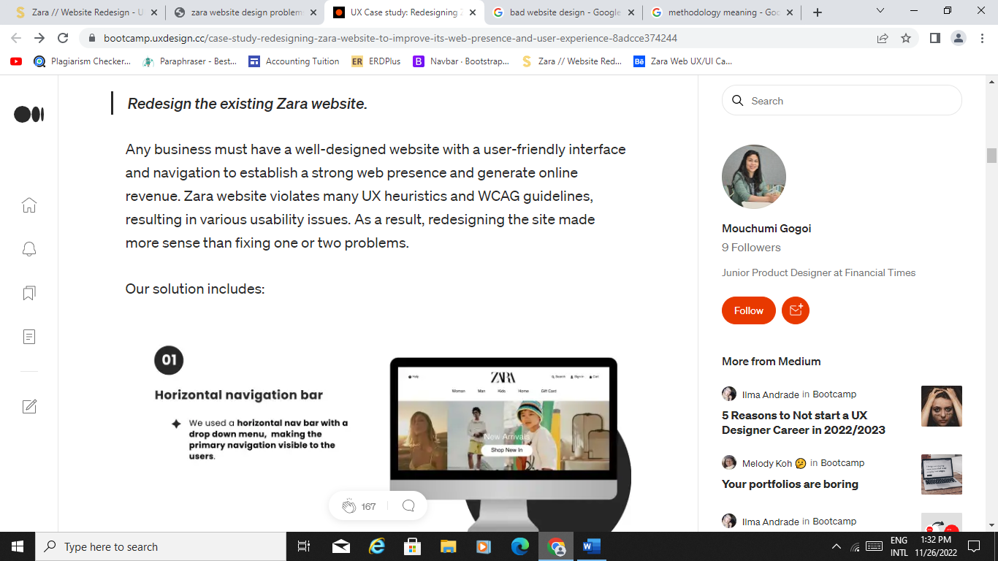

### **The Solution**

I conducted a **usability test** compliant with the Common Industry Format (CIF) methodology with **6 users** and performed a **redesign of the Zara UK website** after identifying **key usability issues** and **formulating recommendations** to **enhance the site’s ease of use** when searching for and purchasing clothing items.

In addition, I created a **style guide**, **task analysis**, and **class diagram** for the redesigned site.

Visiting ZARA's website is reminiscent of flipping through an editorial magazine. It's visually attractive, but shopping itself — which is the goal of site visitors — proves difficult. Consider the homepage of its US site above. The text is small and the navigation menu hides behind a [hamburger button](https://blog.hubspot.com/website/hamburger-button?_ga=2.187328878.790958718.1659707677-1687133060.1659707677), so it's not immediately apparent to users what to do next. With no explicit CTA, visitors can easily become confused or frustrated.

The user journey is also difficult to follow on ZARA's mobile site. When clicking on the hamburger menu on mobile, an unconventional navigation menu reveals itself. Notice that there's no "Clothing" option. Instead, there’s a lengthy list that visitors have to sort through to find what they’re looking for.

Users who forge ahead will find no breadcrumbs or sort options to help them browse. As a result of this poor navigation, users might bounce to a more traditional ecommerce site instead of guessing where to click next.

**How to Improve:**A navigation menu is a central aspect of good usability and is a hallmark of successful websites. While we appreciate Zara's artistic approach to an ecommerce site, user experience should be the priority. With a more straightforward navigation menu and simplifying the user journey, Zara could reduce visitor frustration. We recommend Zara make this navigation menu more visual with icons that add more direction to the browsing experience.

What is the problem? Unconventional navigation.

Visiting ZARA’s website is like looking at an editorial magazine. The design of this website is visually attractive, but shopping, which is the goal of visitors, is difficult.

As you can see, the text on the site is small, and it has a hidden navigation menu (behind a hamburger button.) There is no explicit CTA so the visitors will get confused.

**How to improve:** The user experience should be a priority in designing. How? by placing a more explicit navigation menu and trying to simplify the user journey.

Homepage is minimal, clean but in terms of visual hierarchy its not there. For ex, the ZARA logo is huge.

Option to see more at once, a line with a little circle. For a normal person they would think what is that there is no text indicating what this element does for them. Only if you play around you will know, which a user shouldn’t have to do especially when shopping.

Cart no indication where the fourth one is need to scroll horizontal to know.

===========================================

But, for large corporations like Zara, having a bad website is embarrassing and unacceptable. For a company that is part of Inditex, the [top profitable clothing company](https://www.businessinsider.com/nike-zara-tj-maxx-top-list-global-fashion-brands-2018-12#1-inditex-zara-massimo-dutti-pull-and-bear-10) in the world, Zara’s website needs to be on par with the best clothing sites on the internet. So what makes a good UX design? It takes an [approach](https://xd.adobe.com/ideas/principles/web-design/what-makes-good-ux/) around users and to develop and product a deliverable around the wants and needs of the targeted audience. UX Design is then added with two other [topics](https://xd.adobe.com/ideas/guides/evolution-user-experience-design-intro/): functionality and a “focus on delight.” We are going to use the list of heuristics from the Nielsen Norman Group as a template of principles to breakdown the good and bad about Zara’s website.///

Zara’s brick-and-mortar stores were the major source of revenue. But as coronavirus caused **a 44% sales slump**, Inditex had to **boost online retailing** and **close up to 1200 stores** worldwide./////

Zara’s target demographic is a young price-conscious audience with lower to mid-income levels. They are highly responsive to trends. So, Zara’s strategy is to offer cutting edge fashion at an affordable price. As most of their customers have a clear set of interests and a shared taste for cheap yet high style designer clothes, their value proposition is fashionable and affordable clothes./////**INTRO**

**User Research:**

*Participants feel frustrated and irritated with the current website.*

As the project had a limited timeframe, we created an online questionnaire to understand Zara’s existing customers’ opinions about its current website and better understand their shopping habits.

**Research Plan**

I began by designing a research plan that would help me stay organized but more importantly, on track with the research phase. First, I wanted to conduct one-on-one interviews and surveys with current shoppers and possibly first-time shoppers of Zara. Through user surveys and interviews, I detected patterns on a user’s digital experience. I also wanted to study Zara’s competitors by going through their websites and identify what they are doing right but more importantly what they are doing wrong to make sure this new user interface does not repeat past mistakes.